**Web Application Security**

# **OWASP TOP 10**

To ensure security, there should be no un-authorized access and OWASP all top 10 attacks and vulnerabilities ensure this thing.

Following is the flow of operations showing how and where OWASP is responsible:

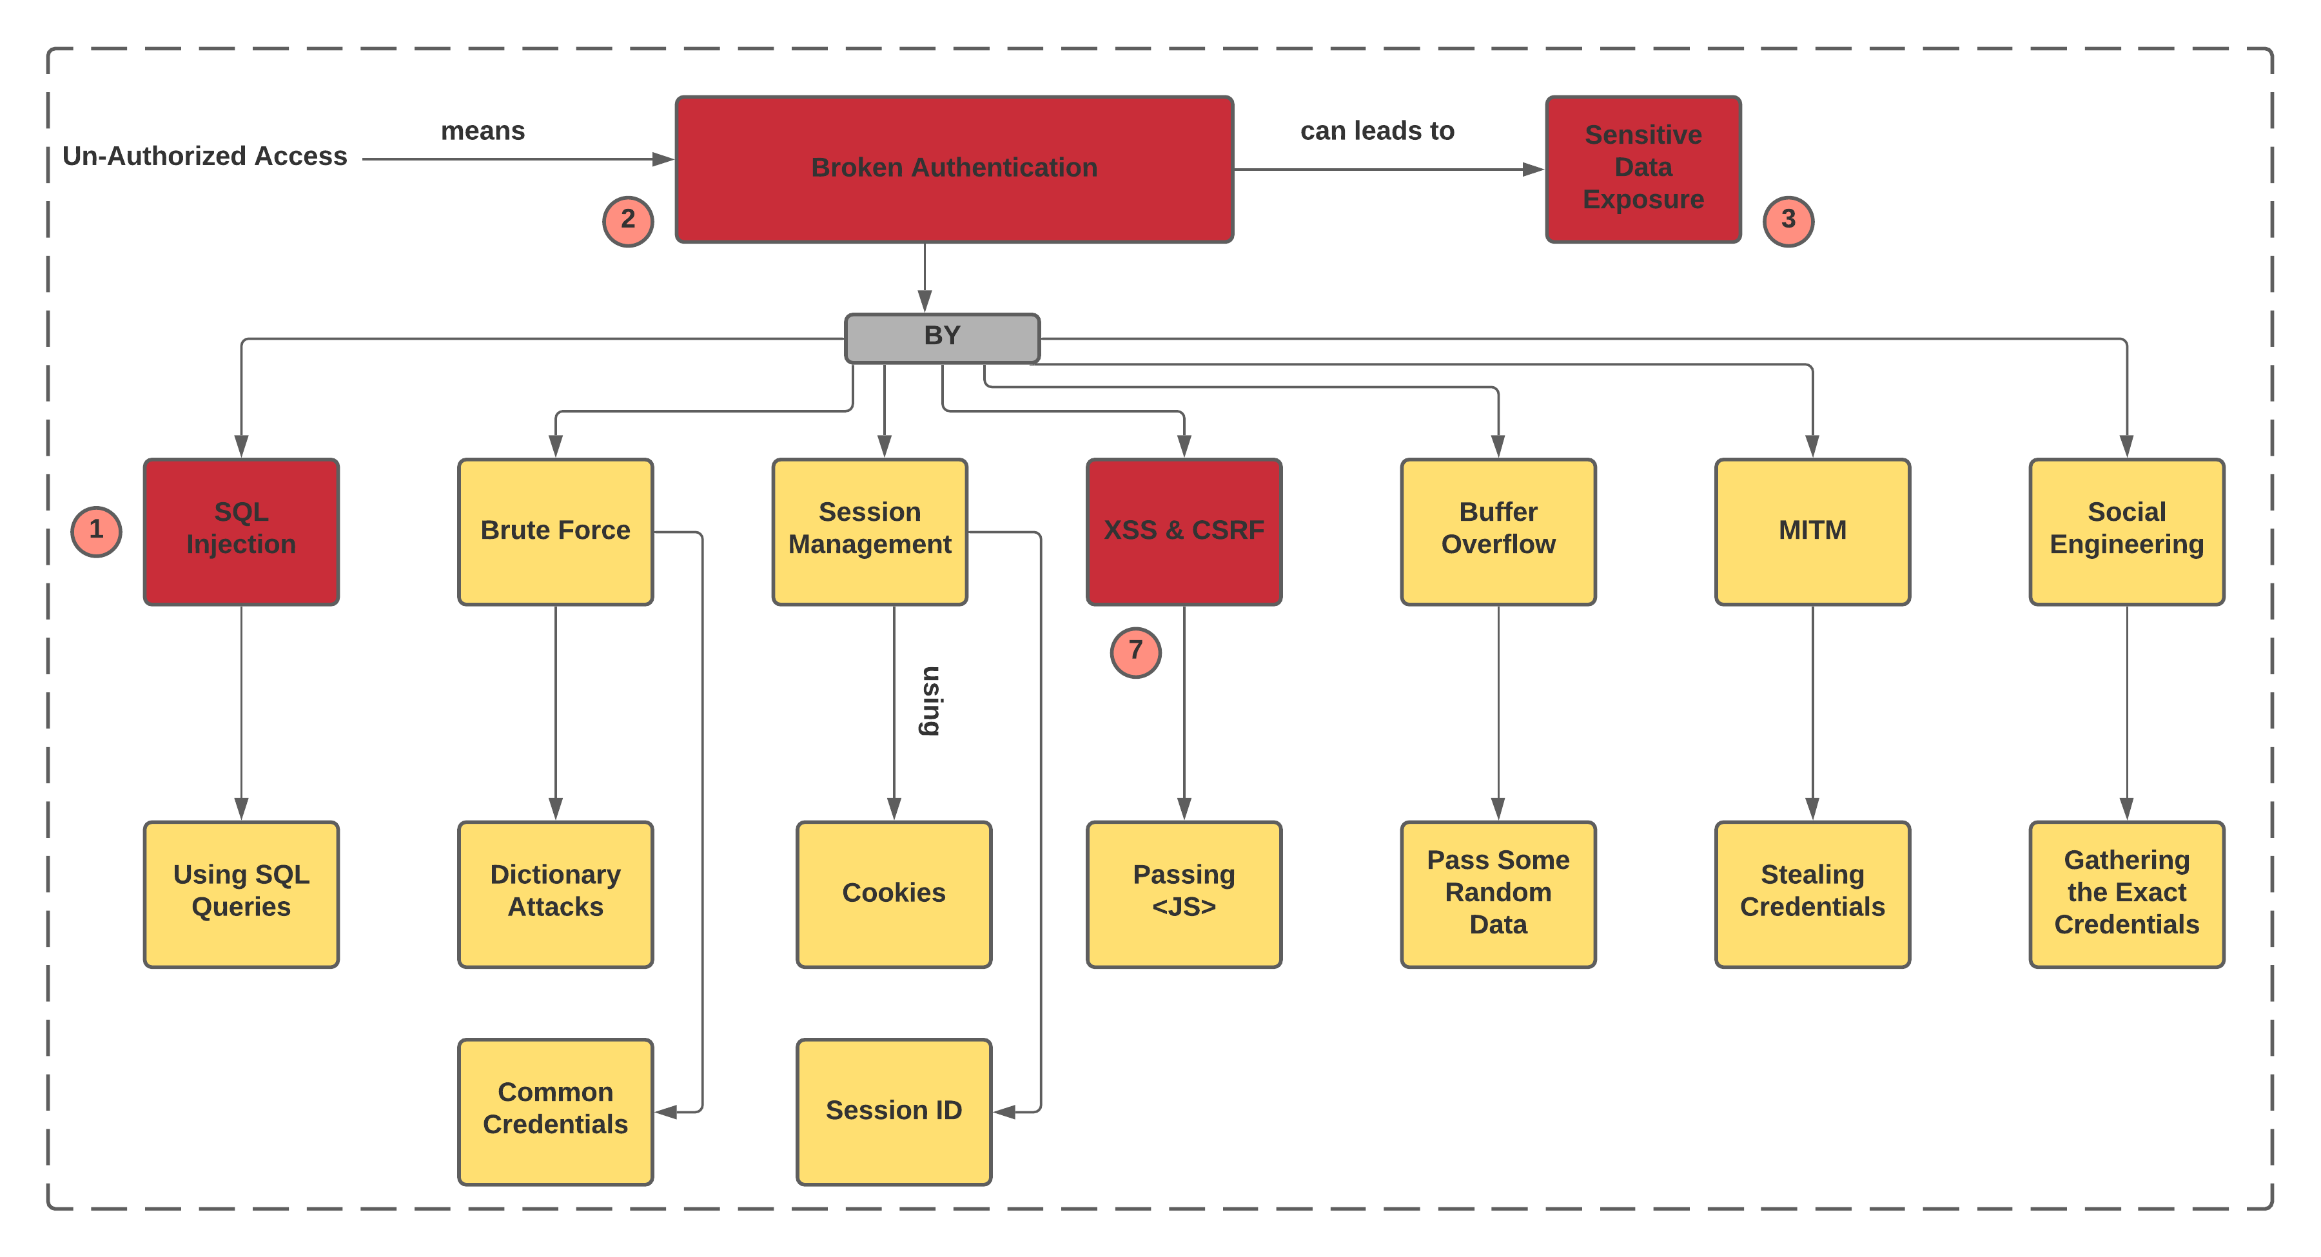

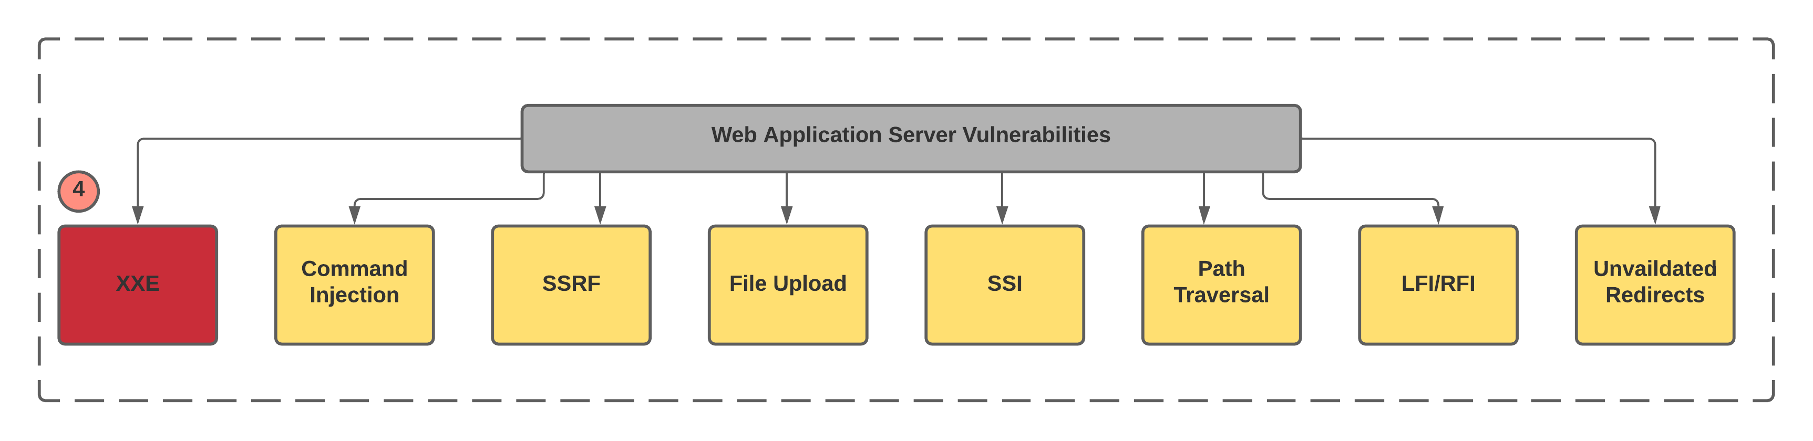

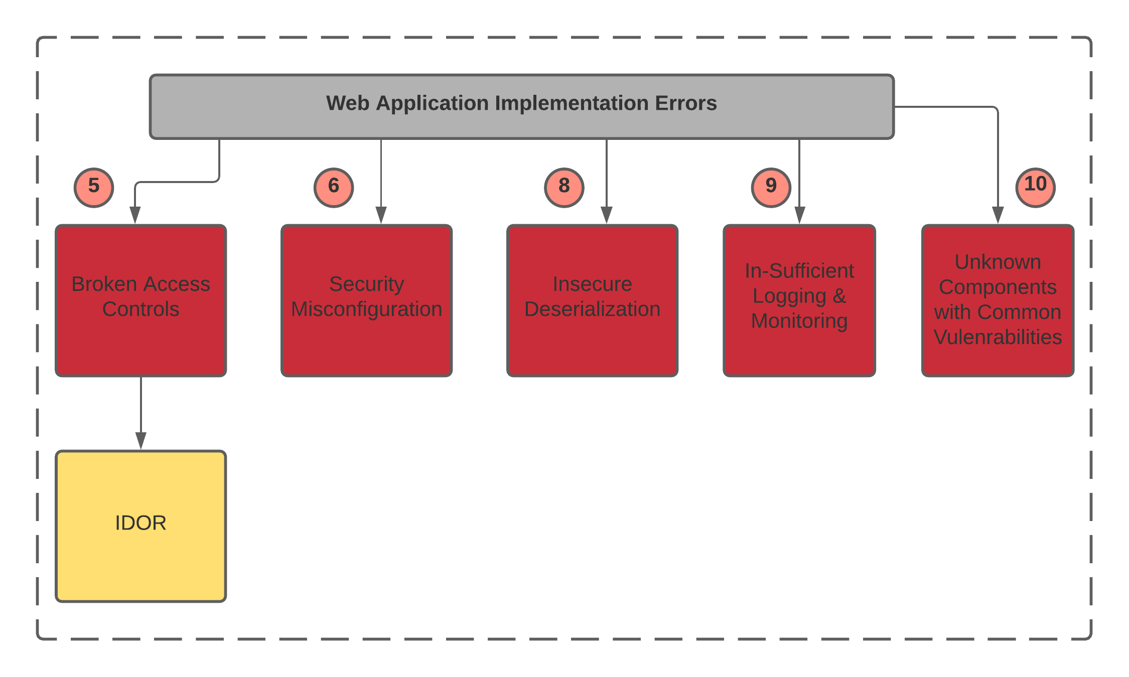

**Abbreviations:**

*XXE: XLM External Entity*

*SSRF: Server-Side Request Forgery*

*SSI: Server-Side Include*

*RFI: Remote File Inclusion*

*LFI: Local File Inclusion*

*IDOR: Insecure direct object references*